**Customizing the Existing admin perspective:**

1. We will see how the existing perspective will be in **platformbackoffice-backoffice-config.xml**

For this perspective we won’t dependent on widget.xml mostly and we will create widget in config.xml with wizard component.

<context component=*"explorer-tree"* merge-by=*"module"*>

<explorer-tree:explorer-tree>

<explorer-tree:navigation-node id=*"hmc_backoffice-workflow-inbox"* position=*"0"*/>

<explorer-tree:navigation-node id=*"hmc_treenode_system"*>

<explorer-tree:navigation-node id=*"hmc_treenode_systemconfig"*>

<explorer-tree:type-node code=*"JaloTranslatorConfiguration"*

id=*"hmc_typenode_jalotranslatorconfiguration"* />

</explorer-tree:navigation-node>

<explorer-tree:navigation-node id=*"hmc_treenode_systemtools"*>

<explorer-tree:type-node code=*"SavedValues"* id=*"hmc_typenode_savedvalues"*/>

</explorer-tree:navigation-node>

</explorer-tree:navigation-node>

<explorer-tree:navigation-node id=*"hmc_treenode_catalog"*>

<explorer-tree:type-node code=*"Catalog"* id=*"hmc_typenode_catalog"*/>

<explorer-tree:type-node code=*"CatalogVersion"* id=*"hmc_typenode_catalogversion"*/>

<explorer-tree:type-node code=*"Category"* id=*"hmc_typenode_category"*/>

</explorer-tree:navigation-node>

<explorer-tree:navigation-node id=*"hmc_treenode_user"*>

<explorer-tree:type-node code=*"company"* id=*"hmc_typenode_company"*/>

<explorer-tree:type-node code=*"UserGroup"* id=*"hmc_typenode_usergroup"*/>

<explorer-tree:type-node code=*"Employee"* id=*"hmc_typenode_employee"*/>

<explorer-tree:type-node code=*"Customer"* id=*"hmc_typenode_customer"*/>

</explorer-tree:navigation-node>

</explorer-tree:explorer-tree>

</context>

**From the above xml we can find the functionality of one explorer tree type node** <explorer-tree:type-node code=*"SavedValues"* ***we can create different components for this node***

***List of components***

1. **component=*"editor-area" ---*** *to provide editor area for the particular node(type)*
2. **component=*"create-wizard" ----*** *to create a wizard of the node(type)*
3. **component=*"base"***
4. **component=*"simple-search" –--***  *we are including particular node(type) in simple search functionality that mean we are allowing simple search to search something with this node attributes*
5. **component=*"advanced-search"----***  *we are including particular node(type) in advanced search functionality that mean we are allowing simple advanced to search something with this node attributes*
6. **component=*"listview" ---***  *it will give the list view for the attributes with are belongs to the node(type)*

<context type=*"SavedValues"* component=*"base"* merge-by=*"type"* parent=*"GenericItem"*>

<y:base>

<y:labels beanId=*"savedValuesLabelProvider"* />

</y:base>

</context>

<context merge-by=*"type"* parent=*"GenericItem"* type=*"SavedValues"* component=*"simple-search"*>

<simple-search:simple-search>

<simple-search:field xmlns=*"http://www.hybris.com/cockpitng/config/simplesearch"*

name=*"modifiedItemDisplayString"*/>

<simple-search:sort-field xmlns=*"http://www.hybris.com/cockpitng/config/simplesearch"* asc=*"false"*

name=*"modifiedItemDisplayString"* />

</simple-search:simple-search>

</context>

<context type=*"SavedValues"* component=*"advanced-search"* merge-by=*"type"* parent=*"GenericItem"*>

<advanced-search:advanced-search>

<advanced-search:field-list>

<advanced-search:field name=*"modifiedItemType"* selected=*"true"*/>

<advanced-search:field name=*"modificationType"* selected=*"true"*/>

<advanced-search:field name=*"user"* selected=*"true"* />

<advanced-search:field name=*"timestamp"* selected=*"true"*/>

<advanced-search:field name=*"modifiedItem"* selected=*"false"*/>

<advanced-search:field name=*"modifiedItemDisplayString"* selected=*"false"*/>

<advanced-search:field name=*"comments"* selected=*"false"*/>

<advanced-search:field name=*"creationtime"* selected=*"false"*/>

<advanced-search:field name=*"itemtype"* selected=*"false"*/>

<advanced-search:field name=*"modifiedtime"* selected=*"false"*/>

<advanced-search:field name=*"owner"* selected=*"false"* />

<advanced-search:field name=*"pk"* selected=*"false"* editor=*"com.hybris.cockpitng.editor.defaultlong"*/>

</advanced-search:field-list>

</advanced-search:advanced-search>

</context>

<context merge-by=*"type"* parent=*"GenericItem"* type=*"SavedValues"* component=*"listview"*>

<list-view:list-view>

<list-view:column qualifier=*"timestamp"* />

<list-view:column qualifier=*"modificationType"* />

<list-view:column qualifier=*"modifiedItemType"* />

<list-view:column qualifier=*"user"* />

<list-view:column qualifier=*"modifiedItemDisplayString"* />

</list-view:list-view>

</context>

<context merge-by=*"type"* parent=*"GenericItem"* type=*"SavedValues"* component=*"editor-area"*>

<editorArea:editorArea name=*""*>

<editorArea:essentials>

<editorArea:essentialSection name=*"hmc.essential"*>

<editorArea:attribute qualifier=*"modifiedItem"* />

</editorArea:essentialSection>

</editorArea:essentials>

<editorArea:tab name=*"hmc.tab.saved.values"*>

<editorArea:section name=*"hmc.section.saved.values"*>

<editorArea:attribute qualifier=*"modificationType"* />

<editorArea:attribute qualifier=*"user"* />

<editorArea:attribute qualifier=*"timestamp"* />

<editorArea:attribute qualifier=*"savedValuesEntries"* />

</editorArea:section>

</editorArea:tab>

<editorArea:tab name=*"hmc.administration"*>

<editorArea:section name=*"hmc.common"*>

<editorArea:attribute qualifier=*"modifiedItemType"* />

<editorArea:attribute qualifier=*"modifiedItemDisplayString"* />

</editorArea:section>

</editorArea:tab>

</editorArea:editorArea>

</context>

**Now we will add new node (type) to the existing tree and create wizard and editor area to that node**

1. customize the admin area tree ***explorer-tree***  *in your own extension-****config.xml***

<context component=*"explorer-tree"* merge-by=*"module"*>

<n:explorer-tree xmlns:n=*"http://www.hybris.com/cockpitng/config/explorertree"*>

<n:navigation-node id=*"hmc_ticketsystemgroup"* merge-mode=*"append"*>

<n:type-node id=*"CsTicketTypeAutoassignment"* code=*"CsTicketTypeAutoassignment"* />

<n:type-node id=*"CsTicketPauseReason"* code=*"CsTicketPauseReason"* />

</n:navigation-node>

<n:navigation-node id=*"hmc_treenode_order"* merge-mode=*"append"*>

<n:type-node id=*"OrderSnapshotConfiguration"* code=*"OrderSnapshotConfiguration"* />

<n:type-node id=*"CsFrequentlyUsedComments"* code=*"CsFrequentlyUsedComments"* />

</n:navigation-node>

</n:explorer-tree>

</context>

Here we will add new node(type) *CsFrequentlyUsedComments to the existing tree*

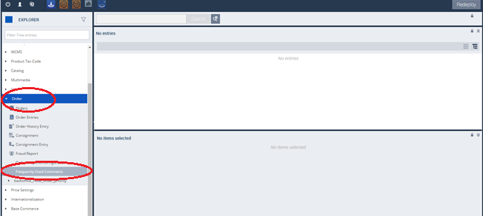

1. we are creating list view for the node *CsFrequentlyUsedComments*

<context type=*"CsFrequentlyUsedComments"* component=*"listview"*>

<list:list-view xmlns:list=*"http://www.hybris.com/cockpitng/component/listView"*>

<list:column qualifier=*"code"*/>

<list:column qualifier=*"text"*/>

<list:column qualifier=*"status"*/>

<list:column qualifier=*"author"*/>

</list:list-view>

</context>

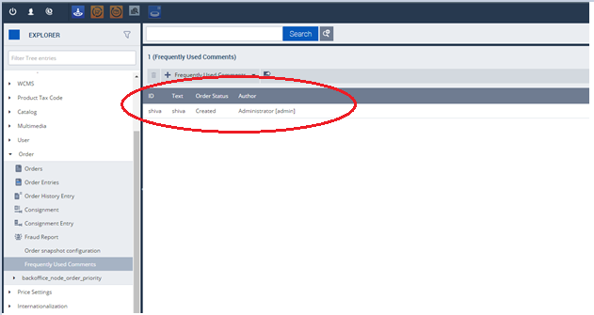

1. providing editor area for the wizard

<context component=*"editor-area"* type=*"CsFrequentlyUsedComments"*>

<editorArea:editorArea xmlns:editorArea=*"http://www.hybris.com/cockpitng/component/editorArea"*>

<editorArea:tab name=*"hmc.tab.CsFrequentlyUsedComments.details"*>

<editorArea:section name=*"hmc.section.CsFrequentlyUsedComments.details"*>

<editorArea:attribute qualifier=*"code"*/>

<editorArea:attribute qualifier=*"text"*/>

<editorArea:attribute qualifier=*"status"*/>

<editorArea:attribute qualifier=*"author"*/>

</editorArea:section>

</editorArea:tab>

</editorArea:editorArea>

</context>

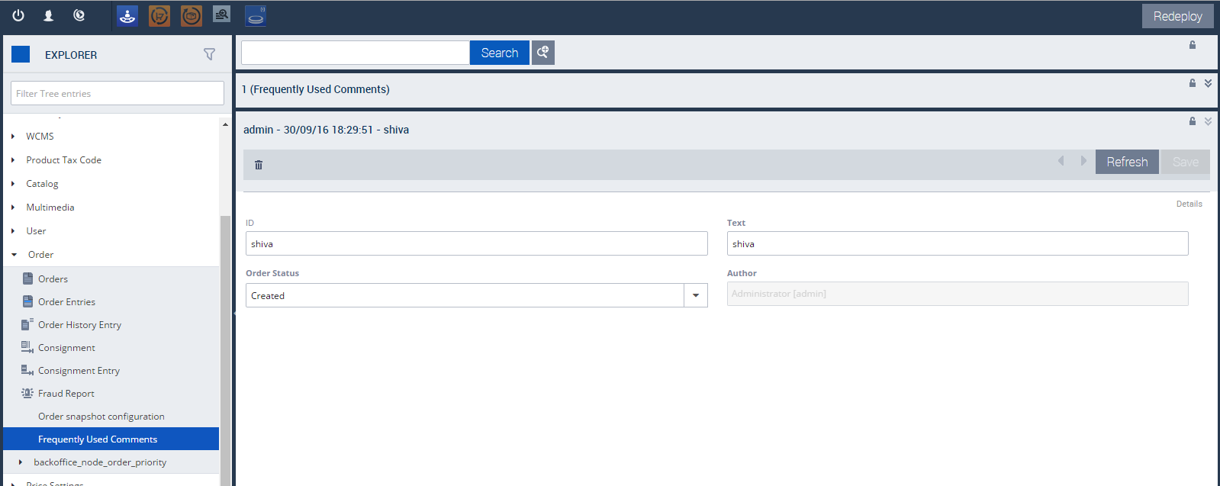

<context type=*"CsFrequentlyUsedComments"* component=*"simple-search"*>

<yss:simple-search xmlns:yss=*"http://www.hybris.com/cockpitng/config/simplesearch"*>

<yss:field name=*"code"*/>

<yss:field name=*"text"*/>

<yss:field name=*"status"*/>

<yss:field name=*"author"*/>

</yss:simple-search>

</context>

<context type=*"CsFrequentlyUsedComments"* component=*"advanced-search"*>

<as:advanced-search xmlns:as=*"http://www.hybris.com/cockpitng/config/advancedsearch"* connection-operator=*"AND"*>

<as:field-list>

<as:field name=*"code"* selected=*"true"*/>

<as:field name=*"text"* selected=*"true"*/>

<as:field name=*"status"* selected=*"true"*/>

<as:field name=*"author"* selected=*"true"*/>

</as:field-list>

</as:advanced-search>

</context>

**In the above wizard if we click on frequently used comments tab in top**

1. create a wizard to provide a wizard when you click on one record

<context type=*"CsFrequentlyUsedComments"* component=*"create-wizard"*>

<wz:flow id=*"CsFrequentlyUsedCommentsWizard"* title=*"create.title(ctx.TYPE_CODE)"*>

<wz:prepare id=*"csFrequentlyUsedCommentsPrepare"*>

<wz:initialize property=*"newItem"* type=*"ctx.TYPE_CODE"*/>

</wz:prepare>

<wz:step id=*"step1"* label=*"create.CsFrequentlyUsedComments.ticket.label"* sublabel=*"create.CsFrequentlyUsedComments.ticket.sublabel"*>

<wz:content id=*"step1.content"*>

<wz:property-list root=*"newItem"*>

<wz:property qualifier=*"code"*/>

<wz:property qualifier=*"text"*/>

<wz:property qualifier=*"status"*/>

</wz:property-list>

</wz:content>

<wz:navigation id=*"step1.navigation"*>

<wz:cancel/>

<wz:done visible=*"!#empty(newItem.code) and !#empty(newItem.text) and newItem.status != null"*>

<wz:save property=*"newItem"*/>

</wz:done>

</wz:navigation>

</wz:step>

</wz:flow>

</context>

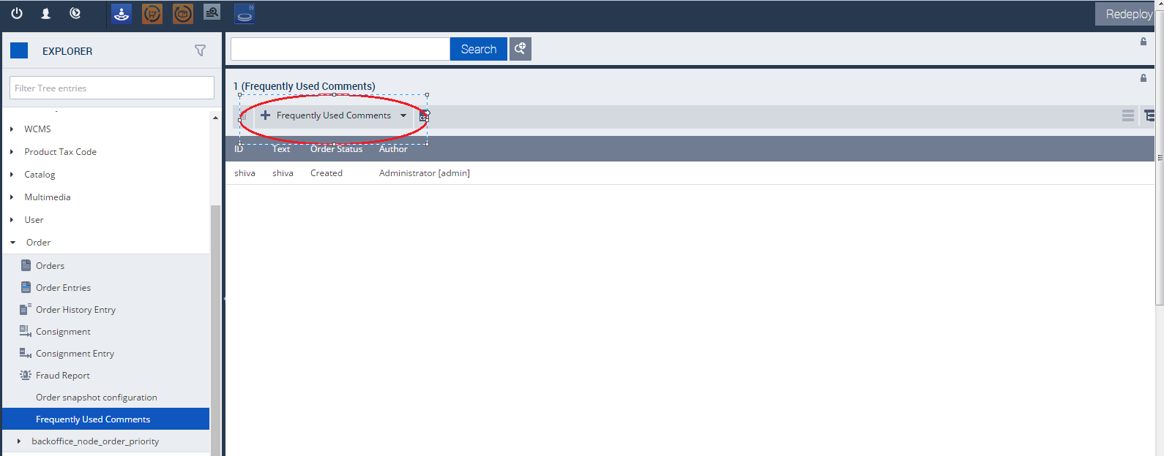

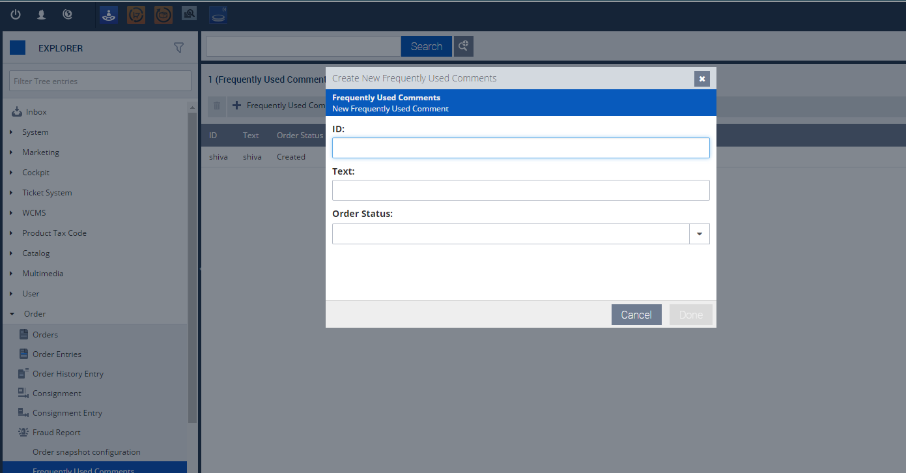

**One More Example**

<context merge-by=*"module"* parent=*"auto"* component=*"explorer-tree"*>

<explorer-tree:explorer-tree xmlns:explorer-tree=*"http://www.hybris.com/cockpitng/config/explorertree"*>

<explorer-tree:navigation-node id=*"hmc_ticketsystemgroup"*>

<explorer-tree:type-node code=*"CsTicket"* id=*"hmc_type_tree_csticket"*/>

<explorer-tree:type-node code=*"CsTicketEventEmailConfiguration"* id=*"CsTicketEventEmailConfiguration"*/>

</explorer-tree:navigation-node>

</explorer-tree:explorer-tree>

</context>

<context merge-by=*"type"* parent=*"GenericItem"* type=*"CsTicket"* component=*"listview"*>

<list-view:list-view xmlns:list-view=*"http://www.hybris.com/cockpitng/component/listView"*>

<list-view:column qualifier=*"ticketID"*/>

<list-view:column qualifier=*"headline"*/>

<list-view:column qualifier=*"customer"*/>

<list-view:column qualifier=*"order"*/>

<list-view:column qualifier=*"state"*/>

<list-view:column qualifier=*"priority"*/>

<list-view:column qualifier=*"category"*/>

</list-view:list-view>

</context>

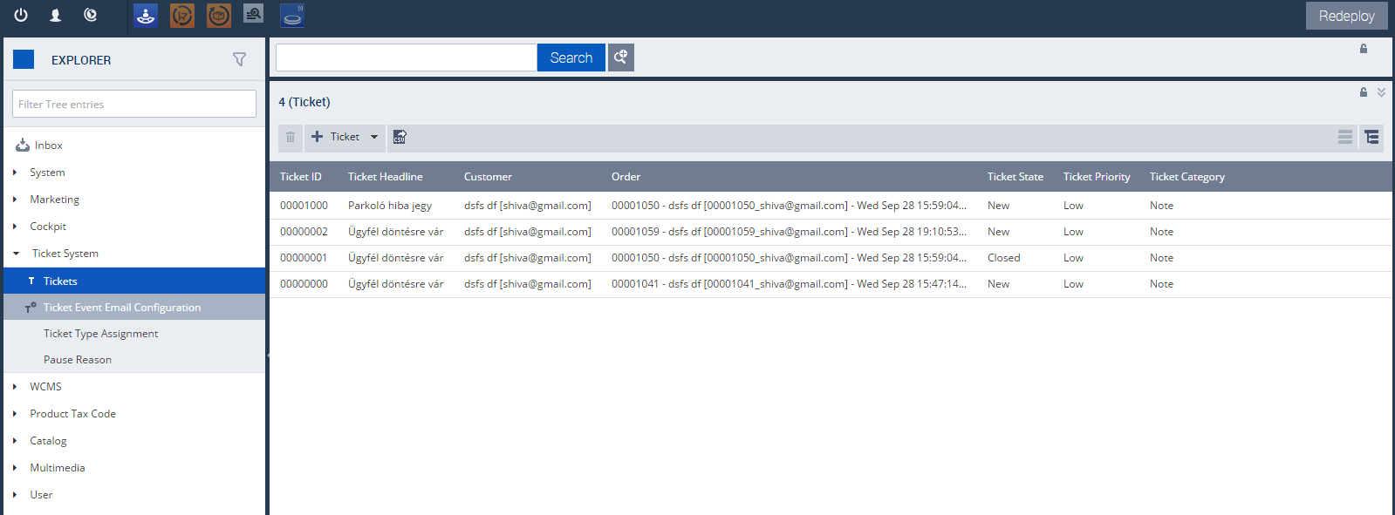

<context merge-by=*"type"* parent=*"GenericItem"* type=*"CsTicket"* component=*"editor-area"*>

<editorArea:editorArea xmlns:editorArea=*"http://www.hybris.com/cockpitng/component/editorArea"*>

<editorArea:tab name=*"hmc.tab.ticket.details"*>

<editorArea:section name=*"hmc.tab.section.ticket.details"*>

<editorArea:attribute xmlns=*"http://www.hybris.com/cockpitng/component/editorArea"* qualifier=*"ticketID"*/>

<editorArea:attribute xmlns=*"http://www.hybris.com/cockpitng/component/editorArea"* qualifier=*"headline"*/>

<editorArea:attribute xmlns=*"http://www.hybris.com/cockpitng/component/editorArea"* qualifier=*"category"*/>

<editorArea:attribute xmlns=*"http://www.hybris.com/cockpitng/component/editorArea"* qualifier=*"state"*/>

<editorArea:attribute xmlns=*"http://www.hybris.com/cockpitng/component/editorArea"* qualifier=*"priority"*/>

</editorArea:section>

<editorArea:section name=*"hmc.tab.section.ticket.associated"*>

<editorArea:attribute xmlns=*"http://www.hybris.com/cockpitng/component/editorArea"* qualifier=*"order"*/>

<editorArea:attribute xmlns=*"http://www.hybris.com/cockpitng/component/editorArea"* qualifier=*"customer"*/>

</editorArea:section>

<editorArea:section name=*"hmc.tab.section.ticket.assigned"*>

<editorArea:attribute xmlns=*"http://www.hybris.com/cockpitng/component/editorArea"* qualifier=*"assignedAgent"*/>

<editorArea:attribute xmlns=*"http://www.hybris.com/cockpitng/component/editorArea"* qualifier=*"assignedGroup"*/>

</editorArea:section>

</editorArea:tab>

<editorArea:tab name=*"hmc.tab.ticket.history"*>

<editorArea:section name=*"hmc.tab.section.ticket.history"*>

<editorArea:attribute xmlns=*"http://www.hybris.com/cockpitng/component/editorArea"* qualifier=*"resolution"*/>

<editorArea:attribute xmlns=*"http://www.hybris.com/cockpitng/component/editorArea"* qualifier=*"events"*/>

</editorArea:section>

</editorArea:tab>

</editorArea:editorArea>

</context>

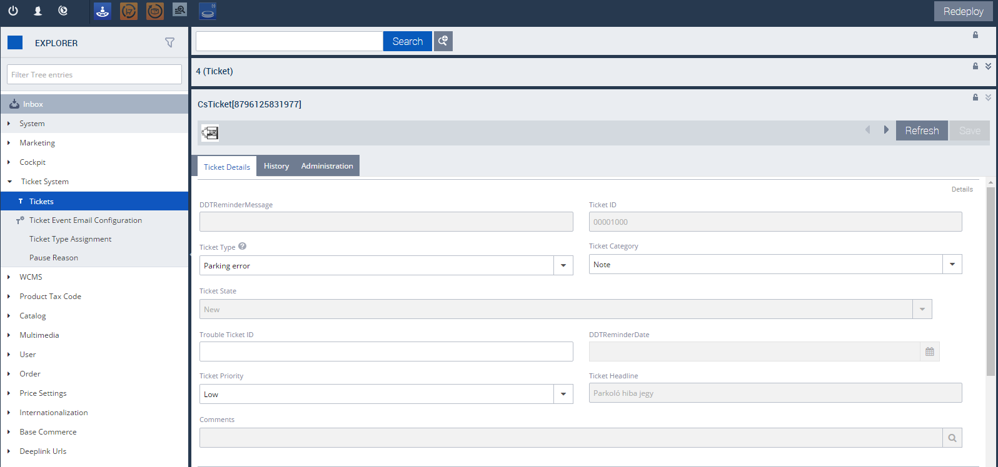

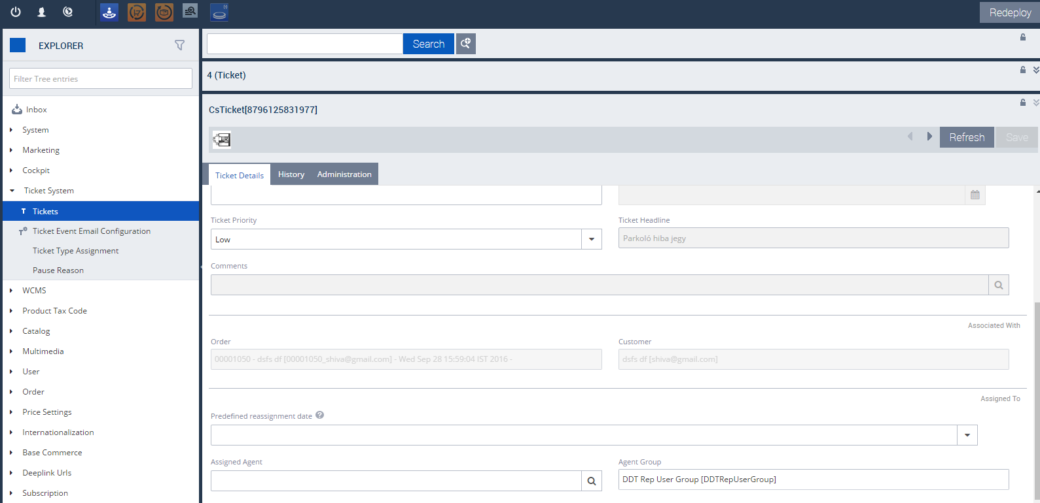

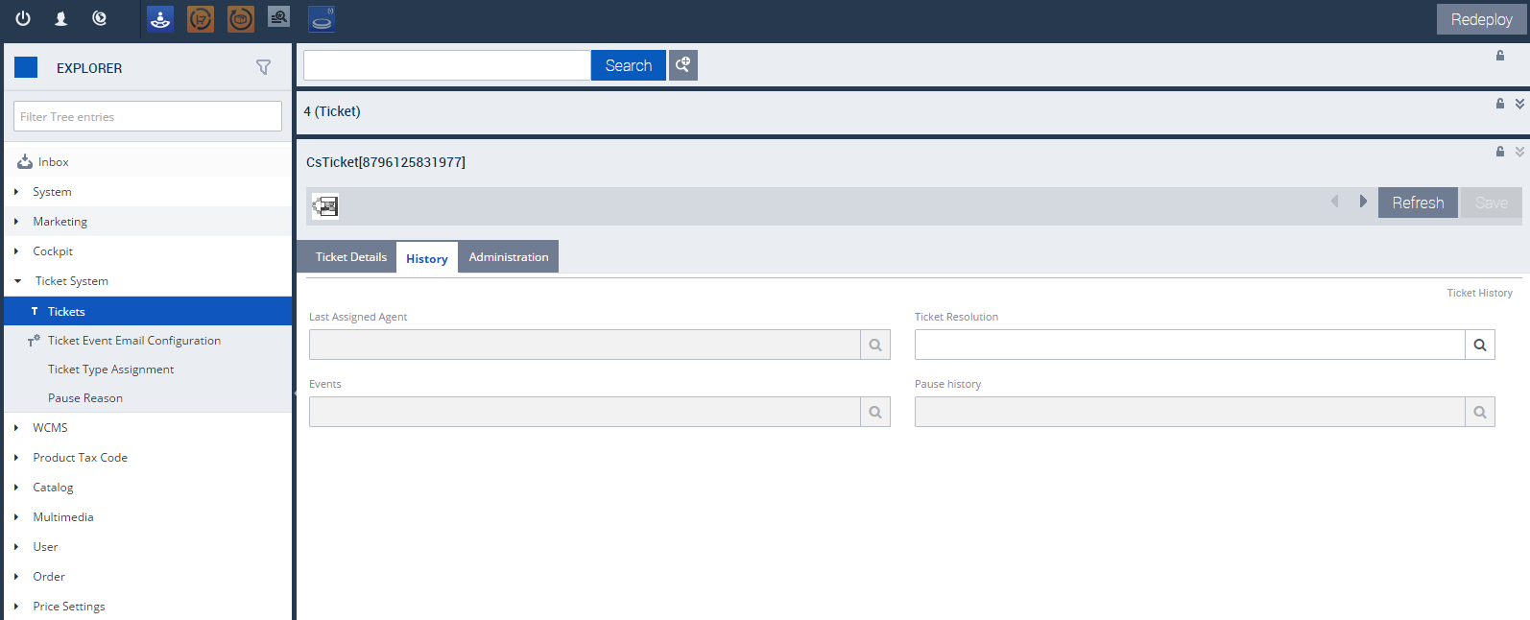

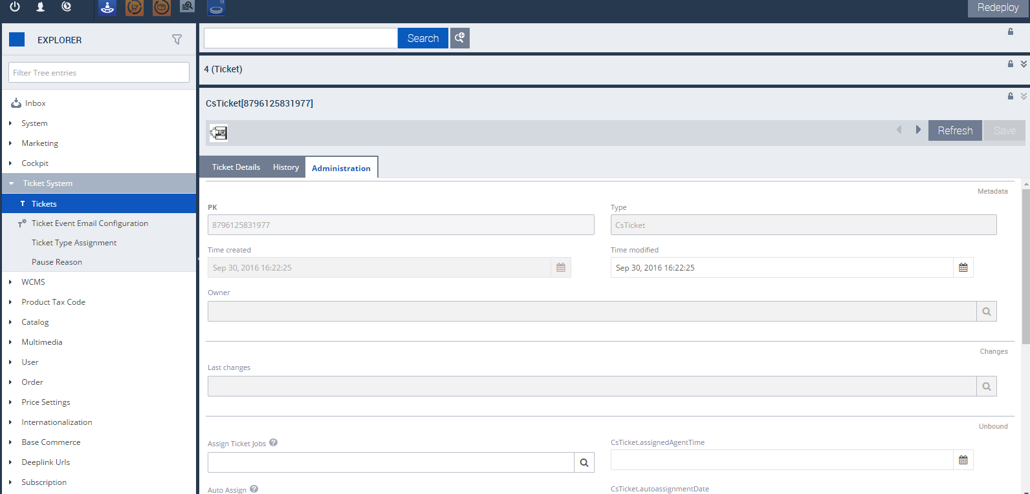

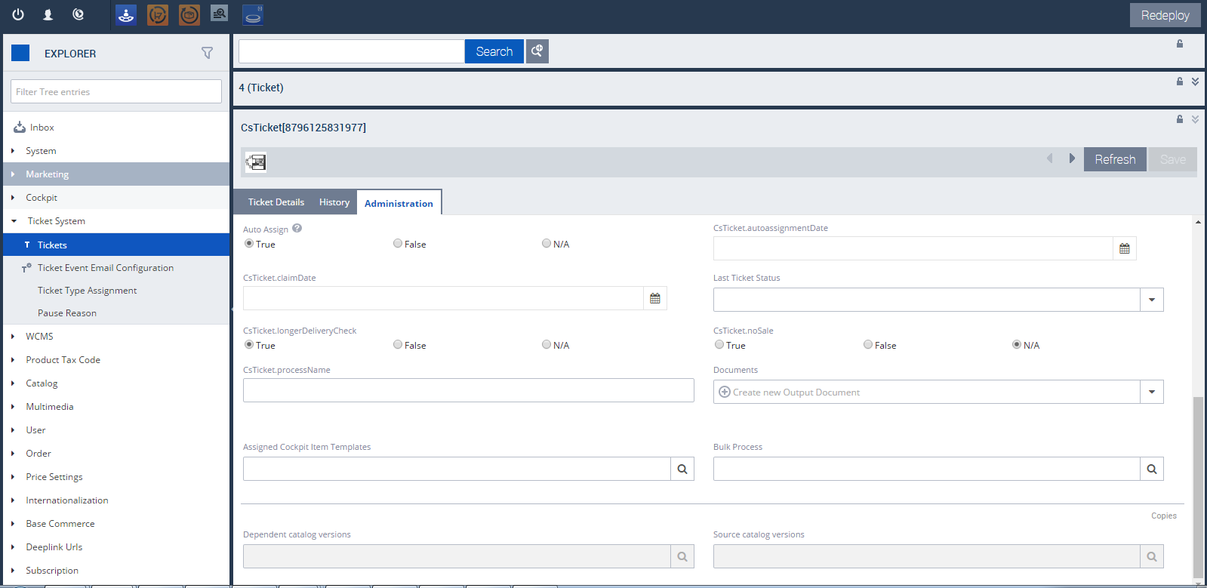

<context merge-by=*"type"* parent=*"GenericItem"* type=*"CsTicket"* component=*"advanced-search"*>

<advanced-search:advanced-search xmlns:advanced-search=*"http://www.hybris.com/cockpitng/config/advancedsearch"*>

<advanced-search:field-list>

<advanced-search:field xmlns=*"http://www.hybris.com/cockpitng/config/advancedsearch"* name=*"assignedAgent"* selected=*"false"*/>

<advanced-search:field xmlns=*"http://www.hybris.com/cockpitng/config/advancedsearch"* name=*"assignedGroup"* selected=*"false"*/>

<advanced-search:field xmlns=*"http://www.hybris.com/cockpitng/config/advancedsearch"* name=*"category"* selected=*"false"*/>

<advanced-search:field xmlns=*"http://www.hybris.com/cockpitng/config/advancedsearch"* name=*"customer"* selected=*"false"*/>

<advanced-search:field xmlns=*"http://www.hybris.com/cockpitng/config/advancedsearch"* name=*"headline"* selected=*"false"*/>

<advanced-search:field xmlns=*"http://www.hybris.com/cockpitng/config/advancedsearch"* name=*"order"* selected=*"false"*/>

<advanced-search:field xmlns=*"http://www.hybris.com/cockpitng/config/advancedsearch"* name=*"priority"* selected=*"false"*/>

<advanced-search:field xmlns=*"http://www.hybris.com/cockpitng/config/advancedsearch"* name=*"resolution"* selected=*"false"*/>

<advanced-search:field xmlns=*"http://www.hybris.com/cockpitng/config/advancedsearch"* name=*"state"* selected=*"false"*/>

<advanced-search:field xmlns=*"http://www.hybris.com/cockpitng/config/advancedsearch"* name=*"ticketID"* selected=*"true"*/>

<advanced-search:field xmlns=*"http://www.hybris.com/cockpitng/config/advancedsearch"* name=*"comments"* selected=*"false"*/>

<advanced-search:field xmlns=*"http://www.hybris.com/cockpitng/config/advancedsearch"* name=*"creationtime"* selected=*"false"*/>

<advanced-search:field xmlns=*"http://www.hybris.com/cockpitng/config/advancedsearch"* name=*"itemtype"* selected=*"false"*/>

<advanced-search:field xmlns=*"http://www.hybris.com/cockpitng/config/advancedsearch"* name=*"modifiedtime"* selected=*"false"*/>

<advanced-search:field xmlns=*"http://www.hybris.com/cockpitng/config/advancedsearch"* name=*"owner"* selected=*"false"*/>

<advanced-search:field xmlns=*"http://www.hybris.com/cockpitng/config/advancedsearch"* editor=*"java.lang.Long"* name=*"pk"* selected=*"false"*/>

</advanced-search:field-list>

</advanced-search:advanced-search>

</context>

<context type=*"CsTicket"* component=*"base"* parent=*"GenericItem"* merge-by=*"type"*>

<y:base xmlns:y=*"http://www.hybris.com/cockpit/config/hybris"*>

<y:labels>

<y:label>ticketID + (headline!=null ? " - " + headline : "")</y:label>

</y:labels>

</y:base>

</context>

<context merge-by=*"type"* type=*"CsTicket"* component=*"create-wizard"*>

<wz:flow xmlns:wz=*"http://www.hybris.com/cockpitng/config/wizard-config"* id=*"csTicketWizard"* title=*"create.title(ctx.TYPE_CODE)"*>

<wz:prepare id=*"csTicketPrepare"*>

<wz:initialize property=*"newItem"* type=*"ctx.TYPE_CODE"*/>

</wz:prepare>

<wz:step id=*"step1"* label=*"create.csTicket.essential.label"* sublabel=*"create.csTicket.essential.sublabel"*>

<wz:content id=*"step1.content"*>

<wz:property-list root=*"newItem"*>

<wz:property qualifier=*"ticketID"*/>

<wz:property qualifier=*"headline"*/>

<wz:property qualifier=*"category"*/>

<wz:property qualifier=*"state"*/>

<wz:property qualifier=*"priority"*/>

</wz:property-list>

</wz:content>

<wz:navigation id=*"step1.navigation"*>

<wz:cancel/>

<wz:next visible=*"!#empty(newItem.ticketID) AND !#empty(newItem.headline) AND newItem.category != null AND newItem.state != null AND newItem.priority != null"*/>

<wz:done visible=*"!#empty(newItem.ticketID) AND !#empty(newItem.headline) AND newItem.category != null AND newItem.state != null AND newItem.priority != null"*>

<wz:save property=*"newItem"*/>

</wz:done>

</wz:navigation>

</wz:step>

<wz:step id=*"step2"* label=*"create.csTicket.association.label"* sublabel=*"create.csTicket.association.sublabel"*>

<wz:content id=*"step2.content"*>

<wz:property-list root=*"newItem"*>

<wz:property qualifier=*"order"*/>

<wz:property qualifier=*"customer"*/>

</wz:property-list>

</wz:content>

<wz:navigation id=*"step2.navigation"*>

<wz:cancel/>

<wz:back/>

<wz:next visible=*"!#empty(newItem.ticketID) AND !#empty(newItem.headline) AND newItem.category != null AND newItem.state != null AND newItem.priority != null"*/>

<wz:done visible=*"!#empty(newItem.ticketID) AND !#empty(newItem.headline) AND newItem.category != null AND newItem.state != null AND newItem.priority != null"*>

<wz:save property=*"newItem"*/>

</wz:done>

</wz:navigation>

</wz:step>

<wz:step id=*"step3"* label=*"create.csTicket.assignment.label"* sublabel=*"create.csTicket.assignment.sublabel"*>

<wz:content id=*"step2.content"*>

<wz:property-list root=*"newItem"*>

<wz:property qualifier=*"assignedAgent"*/>

<wz:property qualifier=*"assignedGroup"*/>

</wz:property-list>

</wz:content>

<wz:navigation id=*"step2.navigation"*>

<wz:cancel/>

<wz:back/>

<wz:done visible=*"!#empty(newItem.ticketID) AND !#empty(newItem.headline) AND newItem.category != null AND newItem.state != null AND newItem.priority != null"*>

<wz:save property=*"newItem"*/>

</wz:done>

</wz:navigation>

</wz:step>

</wz:flow>

</context>

